# Introduction

Looking at the development of the generosity of unemployment benefits in Denmark over time data from ADAM’s databank shows a falling compensation rate in the period of 1990-2018. This is a result of political adjustments deteriorating the income insurance program over time. One of the mostly discussed regulations is the political decision to suppress the regulation of employment benefits in the period of 2016-2023. We use a stock-flow-consistent (SFC) approach to analyze the effects of this decision, building upon the work of (Mikael,Hamid, Sebastian) by integrating the Danish income insurance program, as well as important macroeconomic channels for the program. Using these channels, we obtain an estimate of the macro elasticity of income insurance on unemployment thereby

In 2015 a commission set down by the Danish Ministry of employment (IS-commission) with the goal of analyzing changes to the income insurance program in Denmark, led to the income insurance model. the dynamics of this model was built using aggregated micro effects estimating the change in the exit-rate from unemployment to employment and approach-rate from employment to unemployment as a result of changes in the level of income insurance. The results of this model favored the lower level of income insurance when introducing the suppressing the regulation of the income insurance program. In a response to these results, the worker unions and unemployment insurance companies claimed that the estimates of the micro effects were not correctly estimated and most importantly that the important macroeconomic effects of changes to the level of income insurance were missing in the model.

The popular micro founded models makes it hard to analyze these macroeconomic effects, as the models are usually build using aggregated micro effects as the total macroeconomic effect. Also, these models imply a large focus on the supply side of the economy, thereby tending to ignore the effects of the demand site. Post-Keynesian theory seems to overcome these short comings making it more suitable for this type of analysis, by not building on the narrow micro founded effects. For this reason, we use the framework of a PKSFC- model building on standard accounting principles and explaining the data through equations inspired by post-Keynesian theory. To capture the macro elasticity of the level of income insurance on unemployment we introduce three macroeconomic channels to the model for the income insurance program to affect the economy. The first channel goes through the demand created when raising the income insurance. The demand channel suggests that changes in level of income insurance affect the level of aggregated demand and thereby the demand for employment. (Byrialsen & Raza, 2018) include this channel when analyzing the macroeconomic effects of income insurance. (noget med hvordan dette er lavet I modellen og at det er med i baseline)

The second channel goes through the insurance rate channel, as the income insurance program is not mandatory in Denmark, it is argued by (Aastrup, 2018; Fagbevægelsens Hovedorganisation, 2021; Jensen, 2021) that one should expect a lower compensation rate to also lower the insurance rate (the rate of workers being a member of the income insurance program). We find a significant positive long-run relationship between the insurance rate and compensation rate, which we add into the model when introducing the insurance rate channel.

Lastly, (Andersen et al., 2015) argue that changes in the level of income insurance will affect the wage negotiations, expecting that a higher level of income insurance would increase the targeted wages demanded of the worker unions, who wants to maintain a high incentive to work. Such a channel is included by (Byrialsen & Raza, 2018) including the compensation rate in their wage equation. They argue that incorporating the compensation rate is in line with standard models of wage setting, which plays an important role in the determination of the targeted wage (Mcdonald & Solow, 1981; Shapiro & Stiglitz, 1984).

We introduce this channel looking at the agendas of the labor unions when determining the target wage. First, the worker unions want the wages to follow inflation so that workers keep their purchasing power over time. Second, they set a threshold for the minimum wage gap measuring the difference between the wages and maximum level of income insurance relative to the wages, to maintain a certain incentive to stay employed. In the model the minimum wage gap is set to 42% of the wage[1]. In the case where inflation is not able to close the minimum wage-gap alone (thereby leaving the gap to be below 42% of the wage), the labor unions would set the target wage so that the wage gap is exactly 42% of the wage.

# Results of the simulation

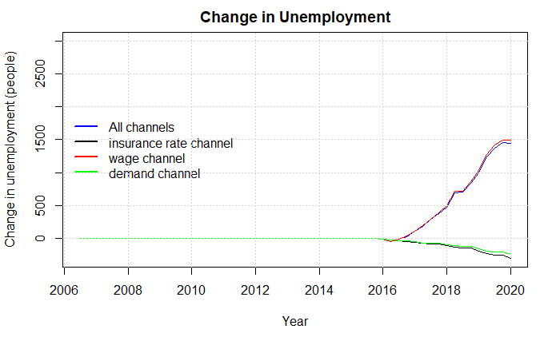

# Main features in the model:

The subject of this paper is to validate the suppressing of the rate regulation percent using the macro elasticity of income insurance on unemployment. In the model presented by (Byrialsen & Raza, 2018) as well as the model used for this paper, unemployment is defined as the difference between the amount of people employed and the labor force, as seen below:

$$Unemp= LF-Emp$$

As the labor force is exogenous, the unemployment is highly dependent on the demand for employment. As mentioned in section 2, post-Keynesian theory suggests that the economy is mostly demand driven, therefor the firms will hire workers to meet a certain demand. This implies that employment is determined by total production and the productivity of workers both in real terms.

$$Emp=0.99*\frac{yk}{prodk}$$

Here we assume that real total production takes place in the non-financial corporations and is determined by the aggregate demand, as seen below

$$y_{t}=c_{t}+i_{t}+g+x-m_{t}$$

For this paper the main effects of income insurance will go through the household’s disposable income and into the consumption of the households ($c_{t}$). We start at the net benefits of the households ($nben_{t}^{h}$) in contrast to the model presented by (Byrialsen & Raza, 2018) we split this into two components ($nbenRest_{t}^{h}$) and ($nbenUn_{t}^{h}$) the later one determining the total amount received by households in income insurance, and the first determining all other benefits but income insurance received by households. The effect of the net benefits of the households then feeds into the disposable income through the component of current transfers ($STR_{t}^{H}$).

$$YD1=\left(1-θ^{H,2}\right)[WB_{t}^{H}+STR_{t}^{H}]$$

For the household’s consumption we find cointegration between the real consumption and both real disposable income and real financial wealth. Therefor the consumption function is estimated using an error correction model, taking the following form:

$$Δ\ln\left(c_{t}\right)=0.76-0.26*\ln\left(c_{t-1}\right)+0.13*\ln\left(yd1_{t-1}\right)+0.05*\ln\left(yd2_{t-1}\right)+0.05*\ln\left(fnw_{t-1}\right)+0.39*Δ\ln\left(c_{t-2}\right)+ 0.19*Δ\ln\left(c_{t-3}\right)+0.12*Δ\ln\left(yd1\right)+0.04*Δ\ln{yd2}$$

Thereby changes to the income insurance program affects the overall economy through changes in demand. In appendix (pg. 51) we have included a DAG presenting the overall flow of the model but for now, we will opt into presenting the central equations for incorporating the income insurance program into the model.

One of the most central components, is the inclusion of the maximum level of income insurance ($Max^{dp}$). Once every year the ministry of finance will set the maximum level of income insurance as of why the variable will only change in the 1. Quarter and stay fixed for the rest of the year. In the baseline model $Max^{dp}$ follows the political regulations stated in the introduction, where it follows that the maximum level of income insurance grows by the state regulation percentage ($statreg$) plus the rate adjustment percentage ($stattilpas$) each year.

$$Max_{t}^{dp}= Max_{t-4}^{dp} +\left(statreg+stattilpas\right)*Max_{t-4}^{dp}$$

As the Ministry of Finance determines the state regulation percentage it is held exogenous in the model. On the other hand, the rate adjustment percentage is calculated each year, using the adaption percentage, following the rules stated earlier in the introduction we need to set up three conditions: First, if the adaption percentage is lower than 0 the rate adjustment percentage is equal to the adaption percentage. Second, if the adaption percentage is between 0.0 - 0.3% the rate adjustment percentage is set to 0. Third, if the adaption percentage is above 0.3% the rate adjustment percentage is equal to the adaption percentage minus 0.3% points.   
As with $Max^{dp}$, the rate adjustment percentage is calculated in the 1. Quarter and held fixed to the end of the year.

The adaption percentage is calculated by taking the wage growth two years before the financial year subtracted by 2% point, it should be noted that we use the yearly wage growth, which in the model is calculated using the 1. Quarter, therefor the adaption percentage is only calculated for 1. Quarter and held constant for the rest of the year.

The endogenization of $Max^{dp}$ is now completed within the model, which now allows us to calculate the compensation rate within the model. The compensation rate is estimated as the fraction of the average amount an unemployed on income insurance would receive ($dpPerson$), to the average wage received by workers ($WageDs$).

$$kompr=\frac{dpPerson}{WageDs}$$

To calculate $dpPerson$ we use a simple OLS regression linking the maximum level of income insurance to the average benefits received by unemployed eligible for income insurance. This is done as an alternative of using aggregated data of benefits received by households, as the gap between observed unemployment and estimated unemployment in the model at some points are quite large, thereby creating a lower average of benefits received. Looking at data from ADAM’s databank we know that approximately 85% receives the maximum level of income insurance meaning that the increase for the people not getting the maximum level would be less. For this reason, we know that the coefficient should be between 0.85 and 1, and most likely closest to 1 as most changes in the income insurance are coming from the change in wage which also affect the level for people not receiving the maximum level. This is also observed as the coefficient estimated is 0.9507 observed below.

$$DpPerson=0.9507*MaxDp$$

The average level of income insurance is then transformed into an aggregate variable, multiplying it by the number of unemployed $(unemp)$ and the insurance rate $(kuld)$ giving the total amount paid in income insurance to the households $nben_{h}^{un}$.

$$nben_{h}^{un}=Dp_{person}*unemp*kuld$$

The total amount paid in income insurance to the households then feeds into the households’ disposable income, as earlier explained, this summarizes the demand channel created in the model for changes to the income insurance program, it should be noted that this effect is not accounted for in the income insurance model.

The total amount of income insurance also feeds into the net lending’s of the government, here it is assumed that the government finances the entire IS-program, which is not the case in reality, the effect of a change in the level of income insurance will therefor overshoot the effect on government net lending.

Another key variable in the labor market is the participation rate, showing the ratio of the population being in the labor force. In the baseline model we keep this variable as exogenous. A main reason for having the participation rate exogenous in the baseline model is that within the dynamics of the Danish labor market, many have failed to determine what brings people into the labor force, in section 2 the literature argued that participation could follow several factors, including norms, wages relative to other workers, consumption levels, and the standard of living. In Scenario 4 we look at a scenario in which the participation rate is made endogenous using the method from (Fazzari et al., 2020) as we find a significant relationship between the unemployment rate and the labor force.

## Validation of the model

In this section we look at the performance of the model, comparing the results from the simulation of the baseline model with actual data, we keep a specific focus on the variables in the labor market.

In the figures below we compare the simulated and actual data for GDP, Employment, maximum level of income insurance and the compensation rate.

Figure

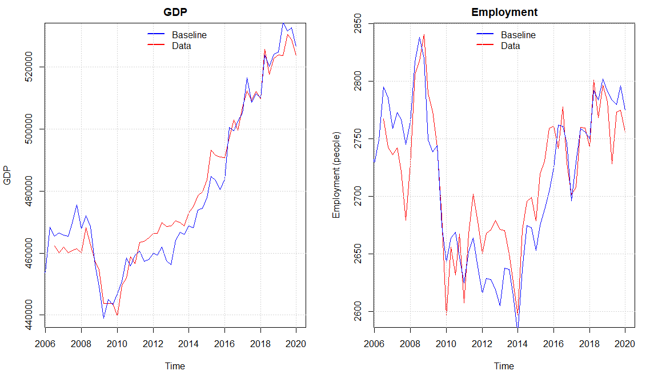

We observe that the model seems to capture the same dynamics of the real economy as (Byrialsen et al., 2022) with a small overshooting of the economic activity in the period 2011 - 2016 explained by a higher simulated value of real investment and consumption compared with the data. Overall, the model seems to capture the medium to long-run tendency of the data even though there are some divergences in some quarters. The Overshooting in the activity also results in a higher level of the maximum level of income insurance in some periods when looking at the baseline model. As the increase in wage growth goes directly into the compensation rate in the same period, meanwhile the maximum level of income insurance will be affected with a lag of 2 years, we observe that the compensation rate is a bit higher in the baseline compared with real data around 2010 - 2012, but as the adjustments to the income insurance through higher wages happens it goes back to follow the real data.

Figure

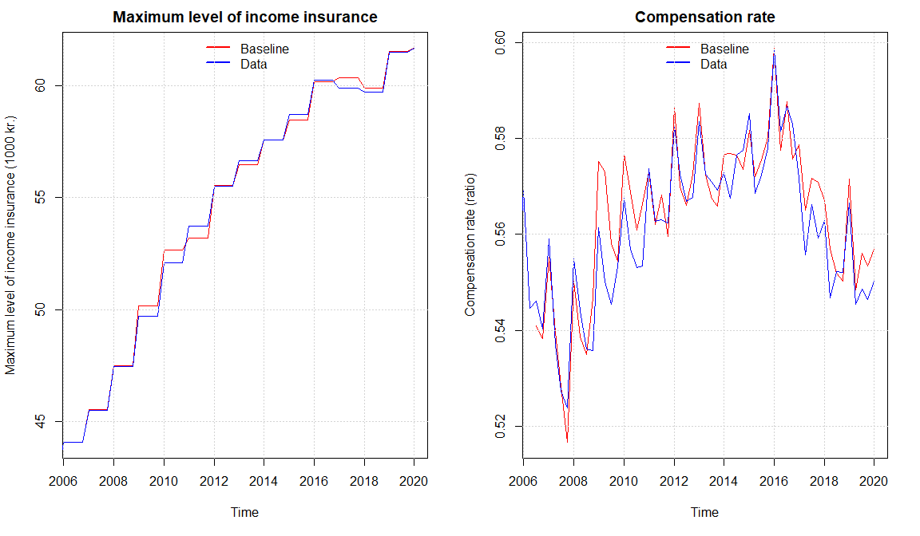

From the figure above we see that the compensation rate is slightly increasing, especially from around 2008-2016, one of the reasons is an ongoing slowdown in the growth rate of the wages. Comparing with the results of (Økonomiske Råd. Formandskabet, 2014) the development fits very well, they as well use a macro-based calculation of the compensation rate. Most importantly we see a fall in the compensation rate in the years of suppressing the regulation of the maximum level of income insurance from 2016. Which was also expected looking at the forecasts made by (Økonomiske Råd. Formandskabet, 2014).

Overall, we see that the data for the labor market is well replicated by the model, creating a basis for analyzing the neglected macroeconomic effects to thereby obtain an estimate of the macro elasticity of the level of income insurance on unemployment, making it possible to analyze the suppressing at the rate regulation rate.

We already introduced a demand channel for the IS-program in the baseline model, therefor when we start to analyze different channels independently it should be noted that the demand channel is still active. In scenario 1 we will introduce the counter factual shock of removing the suppressing of the income insurance to get an estimate of the effect this channel has on the economy and especially unemployment. Next, we start by including more channels for the income insurance to affect the economy. In scenario 2 we introduce the effect of the maximum level of income insurance on the targeted wage, and how this affects the wage negotiating process. In scenario 3 we include the link between the compensation rate and the rate in which people want to be a member of the income insurance programs. In scenario 4 we include an indirect effect of income insurance, when endogenizing the labor force using the unemployment rate as a regressor. In scenario 5 we will look at the match-effect (as a result of the liquidity effect) as well as the Verdoon effect, when explaining productivity. In scenario 6 we introduce all the channels at once, so that the effects of one channel can feed into another.   
We would like to obtain the results of all the channels for the counter factual situation in which the suppressing of the rate regulation is removed, to be able to discuss this in the next section.

1. Which is giving us an elasticity of income insurance on wages close to the one found by (Fredriksson & Söderström, 2020) of 0.2-0.3.